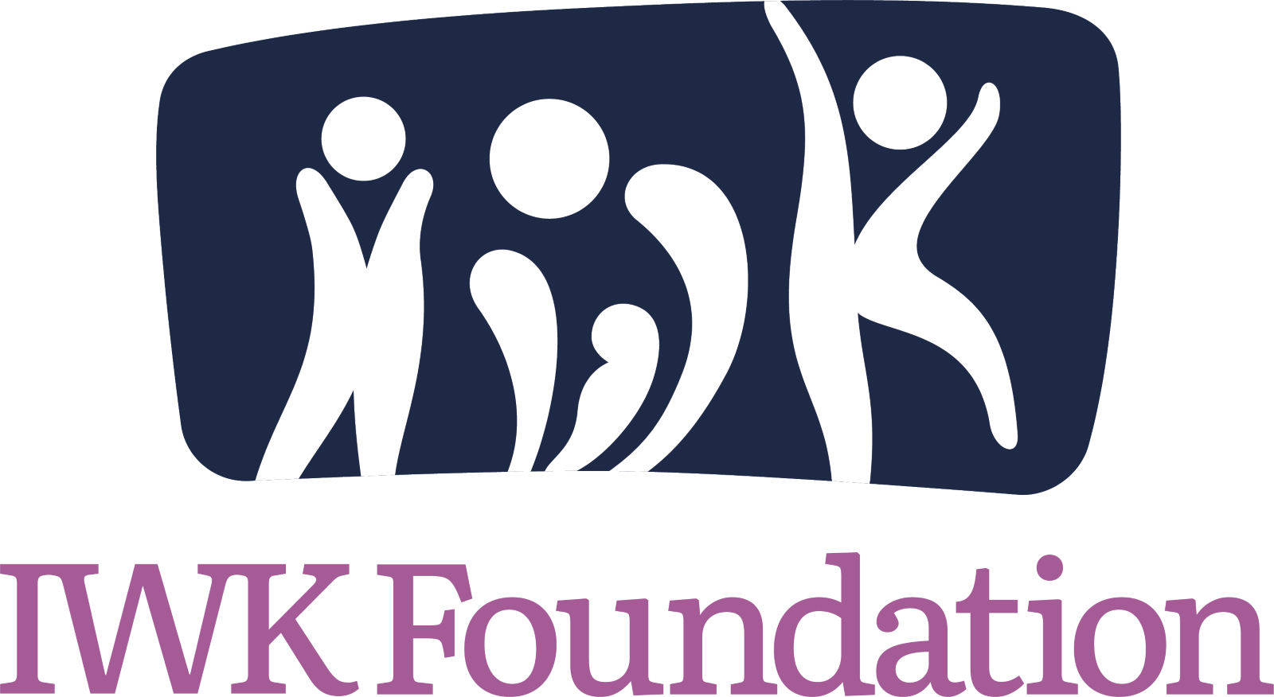
Gifts of Securities
The IWK Foundation welcomes gifts of securities, such as stocks, bonds and mutual funds.
Make your gift today or in your will. As always, the Philanthropy Team is here to help you. If you would like to explore options for use of funds for your donations, please reach out to:
Jyl MacKinnon Robinson at jyl.mackinnon@iwkfoundation.org or by cell: (902) 221-0570 or
Leslie Tinkham at leslie.tinkham@iwkfoundation.org or by cell: (902) 476-3537

MAKE YOUR GIFT IN THREE EASY STEPS:
- Download the Gifts of Securities form and please send the completed document to the IWK Foundation: IWK Donations Team
This is an important step because it notifies the IWK Foundation of your pending gift, allows us to accept the donation, and issue your tax receipt.
- Initiate the share transfer. If applicable, contact your investment advisor who will have you sign a letter of direction outlining the shares you wish to donate. Please see details below.

- When shares have been received, the IWK Foundation will call to thank you and confirm the value of your tax receipt.

Please note: All transfers of securities to the IWK Foundation are subject to review, approval and acceptance by the IWK Foundation. The value of your tax receipt will be based on the price on the day our custodian receives the securities in the Foundation account.
Please note that we are unable to issue a receipt for income tax purposes until we receive your donation.
Thank you for sharing our vision of providing the best care and nothing less for women, infants and children in the Maritimes.

NOTIFICATION OF SECURITIES TRANSFER
To (Name and address of broker/advisor):
I hereby give authorization to provide a charitable gift of securities from my account number:

Signature: ___________________________________
Electronic transfer of shares can be sent to:
Fidelity Clearing Canada ULC
483 Bay St. #200, South Tower
Toronto, ON M5G 2N7

Email: iwkdonations@grayhawkwealth.com
Account Name: IWK Health Centre Foundation
CUID: FIDC
Account Number: F35-0001-A
If you are wanting to discuss transferring a physical share certificate, please call Amy Carr at (902) 221-8976 or e-mail amy.carr@iwkfoundation.org
TO BE COMPLETED BY DONOR:
Name of Donor: Click or tap here to enter text.
Daytime Telephone: Click or tap here to enter text.
Donor’s Address: Click or tap here to enter text.
Donor’s Email: Click or tap here to enter text.
Name of Donor’s Broker: Click or tap here to enter text.
Broker’s Telephone: Click or tap here to enter text. Firm: Click or tap here to enter text.
Name of Security: | Number of Shares Transferred: | CUSIP # of Security being donated:
Thank you for impacting patient care for the Maritime’s women, children & youth!
Signature: ____________________________ Click or tap to enter a date.

5855 Spring Garden Road, Suite B220  Halifax, Nova Scotia B3H 4S2  T (902) 470-8085 | TF 1-800-595-2266 | IWK Foundation Charitable Registration No. 867558090RR0001  foundation@iwkfoundation.org  iwkfoundation.org

